- Join Quota=Joining Quota (don’t allow to create any more option)(it should be created from a menue we will provide, not from here)
- Move Quota= ‘Joining Quota’ to joining record Done
- Divorced = (Spouse Name should not be here) Done
- CHILDREN DETAILS (add a line is not working) working with an extra step pending
- add Home District to personal information Added But Confusion is permanent address/district and home district same?
- Educational Qualification এর মধ্যে GPA/CGPA column বাদ দিতে হবে+ Grading System এর নাম বদলে Division/ CGPA করতে হবে done
- Disciplinery Actions (Should Be Like=
Nature of offence | Date of Punishment | Punishment | Remarks | Upload Document
Done

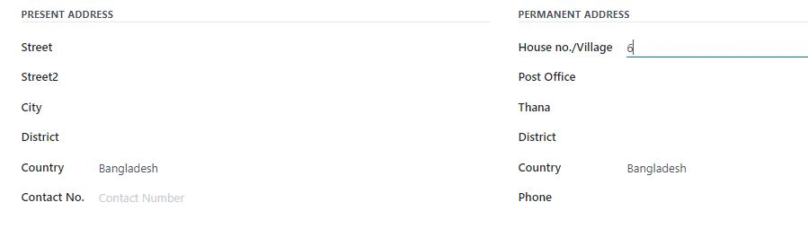
House

Street

post Office

Thana

District
Pls omit country here

House

Street

post Office

Thana

District
Pls omit country here

Done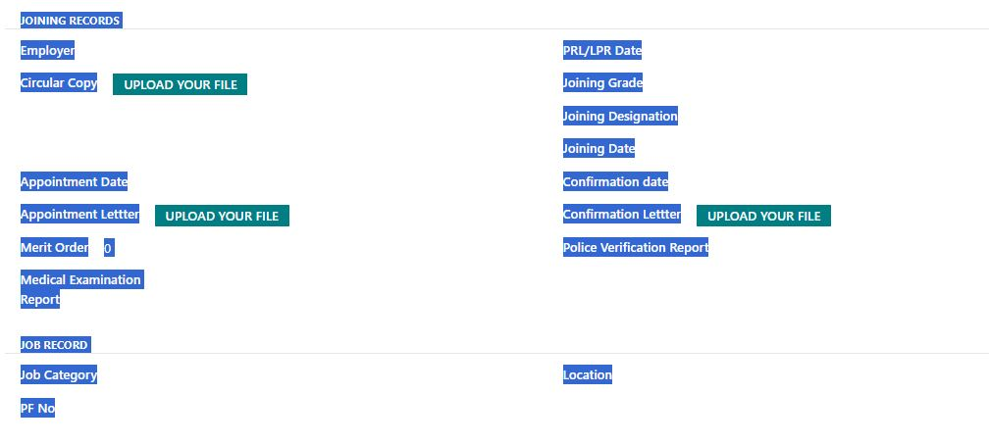
09. job record এখানে দরকার নেই (Posting and transfer এর আগে হবে।
10. Posting and transfer part এ Posting and transfer কথাটা মুছে গেছে।

11. Pls maintain the serial and include all of the following: (Under Joining Record)
Employing Authority | Merit Order
Joining Designation | Joining Grade
Joining Date | Joining letter (Upload)
Circular Date | Circular Copy (Upload)
Appointment Date | Appointment letter (Upload)
Conformation Date | Conformation Letter (Upload)
PRL Date | Provident Fund No.
Police Verification Report (Upload) | Medical Examination Report (Upload)
Joining Quota (Upload)
Ethnic Minority
Freedom fighter
Disability

Job Category | Location
Batch | Cadre (For Deputation)

Done

